SCD Type 2 Project Documentation
Project Title
SCD Type 2 Implementation Using Azure Databricks, PySpark, Azure Blob Storage, Azure SQL Database, and Azure Data Factory

1. Introduction
This project explains the implementation of SCD Type 2 using Azure services and PySpark.
Main purpose of project:
- Read employee CSV files
- Store files in Azure Blob Storage
- Process data using Azure Databricks
- Compare old and new employee records
- Detect changed and new records
- Maintain historical employee data
- Load final data into Azure SQL Database
This project is mainly used in:
- ETL Process
- Data Warehouse
- Historical Data Tracking

2. Technologies Used
Microsoft Azure : Cloud Platform
Azure Blob Storage : Store CSV files
Azure Databricks : Process data
PySpark : Data transformation
Azure SQL Database : Store final data
Azure Data Factory : Pipeline automation

3. Project Flow
CSV Files
↓
Azure Blob Storage
↓
Azure Databricks Notebook
↓
PySpark SCD Type 2 Logic
↓
Azure SQL Database
↓
Azure Data Factory Pipeline

4. Azure Blob Storage
Created Azure Blob Storage account.
Storage Account Name
vjtstoacct
Container Name
input
Purpose:
- Store employee CSV files.

5. CSV Files Used
First CSV File
File Name:
emp_21July2025.csv
Data
EmpID | EmpName | EmpSal | EmpAdd
11 | Ajay | 20000 | Pune
12 | Amit | 25000 | Mumbai

Second CSV File
File Name:
emp_23July2025.csv
Data
EmpID | EmpName | EmpSal | EmpAdd
11 | Ajay | 20000 | Hyd
12 | Amit | 25000 | Mumbai
13 | Kawal | 30000 | Nasik

6. SQL Target Table
Table Name:
DimEmployee
SQL Query
CREATE TABLE DimEmployee
(
Emp_key INT IDENTITY(1,1) PRIMARY KEY,
EmpID INT,
EmpName VARCHAR(100),
EmpSal INT,
EmpAdd VARCHAR(100),
St_dt DATE,
End_dt DATE
);

7. PySpark Code
Import Libraries
from pyspark.sql.functions import *
from pyspark.sql.window import Window

Storage Account Connection
spark.conf.set(
"fs.azure.account.key.vjtstoacct.dfs.core.windows.net",
"Storage_Account_Key"
)

Read First CSV File
initial_df = spark.read.format("csv") \
.option("header", "true") \
.load("abfss://input@vjtstoacct.dfs.core.windows.net/emp_21July2025.csv")

Add Start Date and End Date
initial_df = initial_df.withColumn(
"St_dt",
lit("2025-07-21")
).withColumn(
"End_dt",
lit("9999-12-31")
)

6. Azure SQL Database
Created Azure SQL Database connection.
jdbc_url = "jdbc:sqlserver://vjysqlsrvr.database.windows.net:1433;database=db01"
connection_properties = {
"user": "admin11",
"password": "admin@11",
"driver": "com.microsoft.sqlserver.jdbc.SQLServerDriver"
}

Write Initial Data into SQL Table/Read Target Table
initial_df.write.jdbc(
url=jdbc_url,
table="DimEmployee",
mode="overwrite",
properties=connection_properties
)

Read Second CSV File
source_df = spark.read.format("csv") \
.option("header", "true") \
.load("abfss://input@vjtstoacct.dfs.core.windows.net/emp_23July2025.csv")

Remove Duplicate Records
window_spec = Window.partitionBy("EmpID") \
.orderBy(col("EmpAdd").desc())
source_latest_df = source_df.withColumn(
"rn",
row_number().over(window_spec)
).filter(
col("rn") == 1
).drop("rn")

Read Target Table
target_df = spark.read.jdbc(
url=jdbc_url,
table="DimEmployee",
properties=connection_properties
)

Filter Active Records
active_df = target_df.filter(
col("End_dt") == "9999-12-31"
)
Logic
9999-12-31 means active current record

Join Source and Target Data
join_df = source_latest_df.alias("src").join(
active_df.alias("tgt"),
col("src.EmpID") == col("tgt.EmpID"),
"left"
)
Logic
Used left join because:
- Keep all source records
- Detect changed records
- Detect new records

Identify Changed Records
changed_df = join_df.filter(
(
(col("src.EmpAdd") != col("tgt.EmpAdd")) |
(col("src.EmpSal") != col("tgt.EmpSal")) |
(col("src.EmpName") != col("tgt.EmpName"))
) &
col("tgt.EmpID").isNotNull()
)
Logic
Checks:
- Address changed
- Salary changed
- Name changed
If changed:
- Old record expires
- New record inserted

Identify New Records
new_df = join_df.filter(
col("tgt.EmpID").isNull()
)
Logic
Finds new employees not present in target table.

Get Changed Employee IDs
changed_keys_df = changed_df.select(
col("src.EmpID").alias("EmpID")
).distinct()

Get Unchanged Records
unchanged_df = active_df.join(
changed_keys_df,
"EmpID",
"left_anti"
)
Logic
Keeps records where no changes happened.

Expire Old Records
expired_df = active_df.join(
changed_keys_df,
"EmpID",
"inner"
).withColumn(
"End_dt",
lit("2025-07-22")
)
Logic
Old records become inactive.

Insert Updated Records
updated_insert_df = changed_df.select(
col("src.EmpID").alias("EmpID"),
col("src.EmpName").alias("EmpName"),
col("src.EmpSal").alias("EmpSal"),
col("src.EmpAdd").alias("EmpAdd")
).withColumn(
"St_dt",
lit("2025-07-23")
).withColumn(
"End_dt",
lit("9999-12-31")
)
Logic
Insert latest updated employee records.

Insert New Records
new_insert_df = new_df.select(
col("src.EmpID").alias("EmpID"),
col("src.EmpName").alias("EmpName"),
col("src.EmpSal").alias("EmpSal"),
col("src.EmpAdd").alias("EmpAdd")
).withColumn(
"St_dt",
lit("2025-07-23")
).withColumn(
"End_dt",
lit("9999-12-31")
)

Create Final DataFrame
final_df = unchanged_df \
.unionByName(expired_df) \
.unionByName(updated_insert_df) \
.unionByName(new_insert_df)
Logic
Combines:
- Unchanged records
- Expired records
- Updated records
- New records

Display Final Output
display(final_df)

Write Final Data into SQL Table
final_df.write.jdbc(
url=jdbc_url,
table="DimEmployee",
mode="overwrite",
properties=connection_properties
)

9. Final Output Table
Emp_key | EmpID | EmpName | EmpSal | EmpAdd | St_dt | End_dt
1 | 11 | Ajay | 20000 | Pune | 2025-07-21 | 2025-07-22
2 | 12 | Amit | 25000 | Mumbai | 2025-07-21 | 9999-12-31
3 | 11 | Ajay | 20000 | Hyd | 2025-07-23 | 9999-12-31
4 | 13 | Neha | 30000 | Delhi | 2025-07-23 | 9999-12-31

10. Final SCD Type 2 Logic
Situation | Action
Data changed | Expire old record + Insert new record
New employee | Insert new record
No change | Keep existing active record

11. Azure Data Factory Pipeline
Created Azure Data Factory pipeline.
Pipeline Steps:
- Connect Databricks notebook
- Trigger notebook execution
- Read CSV files from Blob Storage
- Process SCD Type 2 logic
- Load final data into Azure SQL Database
Purpose:
- Automate complete ETL process.

12. Advantages of SCD Type 2
- Maintains history
- No data loss
- Tracks employee changes
- Useful for auditing
- Used in data warehouse projects

13. Conclusion
This project successfully implemented SCD Type 2 using:
- Azure Blob Storage
- Azure Databricks
- PySpark
- Azure SQL Database
- Azure Data Factory
The system:
- Reads employee CSV files
- Detects changed records
- Maintains history
- Expires old records
- Inserts updated records
- Loads final data into SQL Database
- Automates ETL processing using ADF pipeline
System Execution Screenshots

1)Blob Container Creation
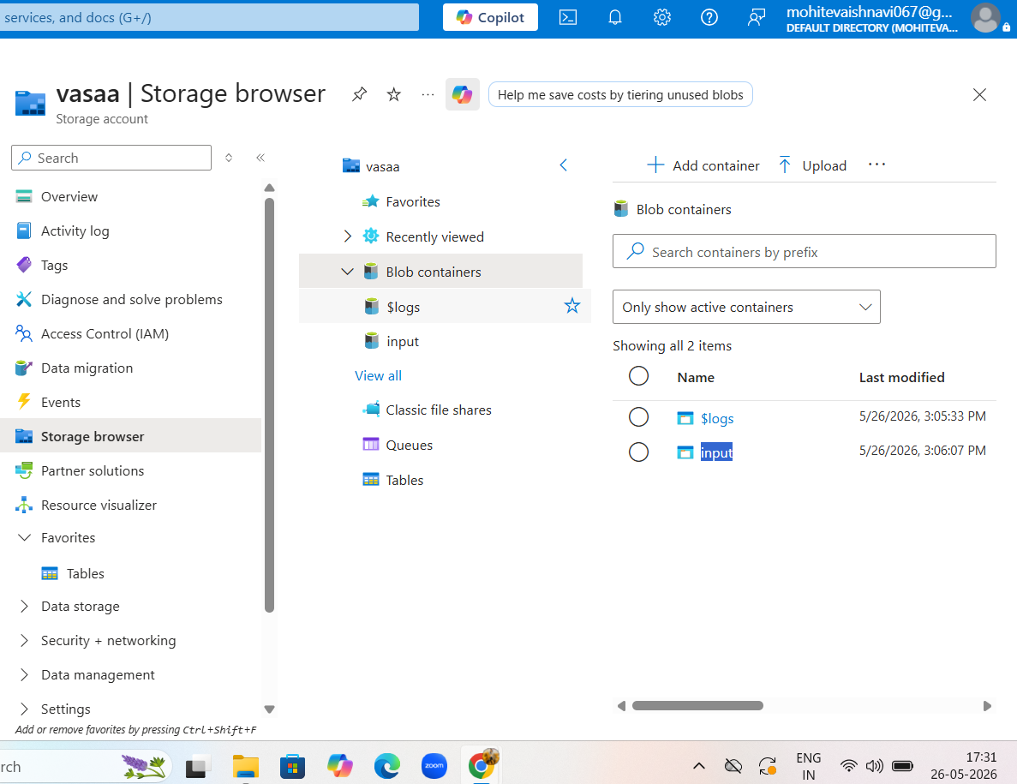

2) CSV File Upload in Blob Storage
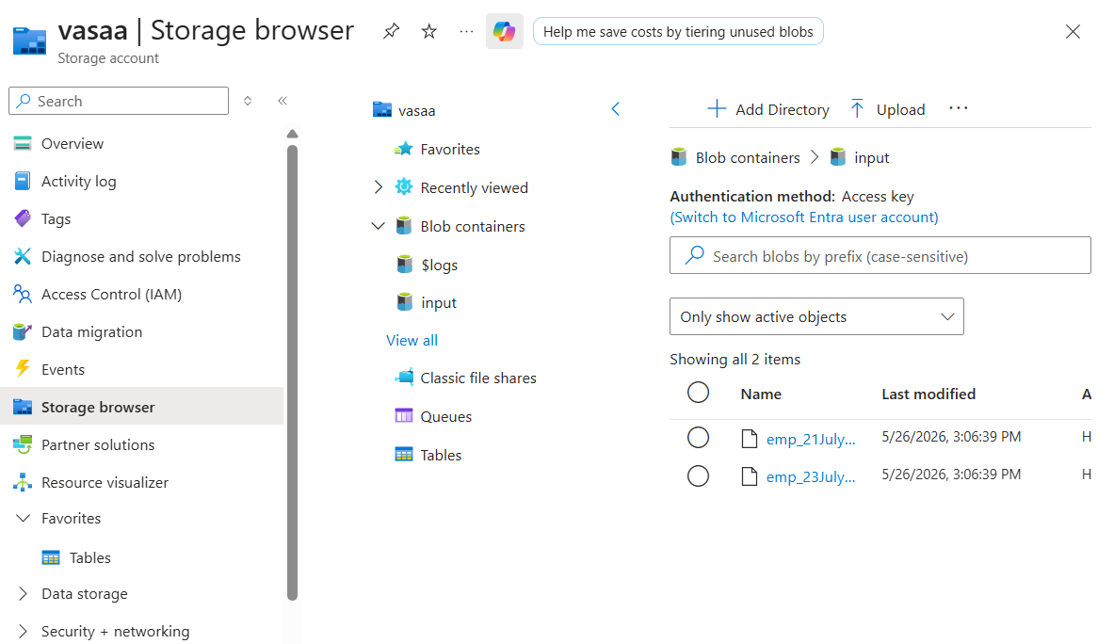

3) SQL Database
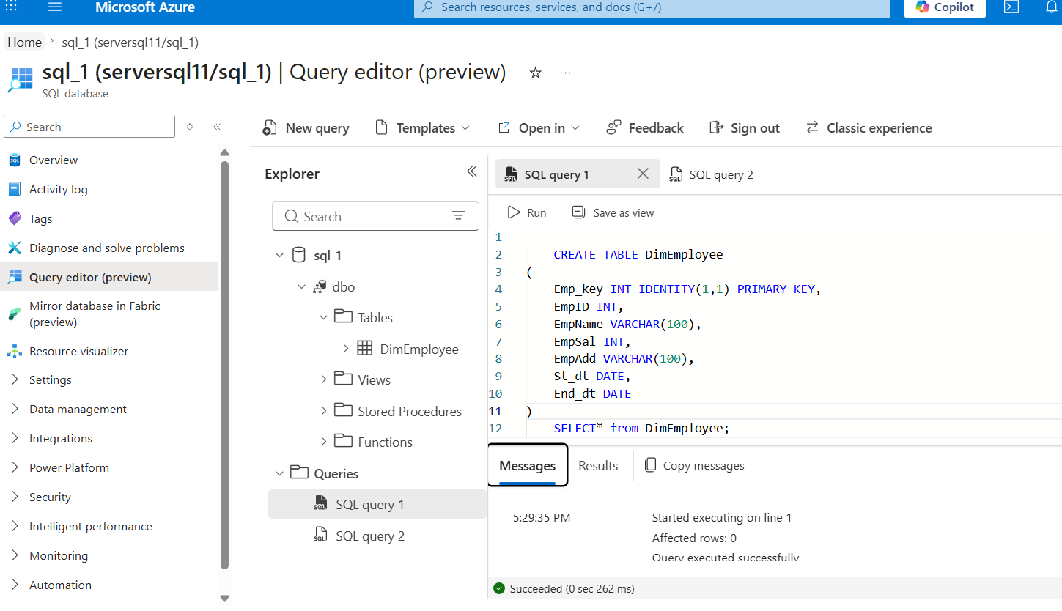

4)Azure Databricks Workspace
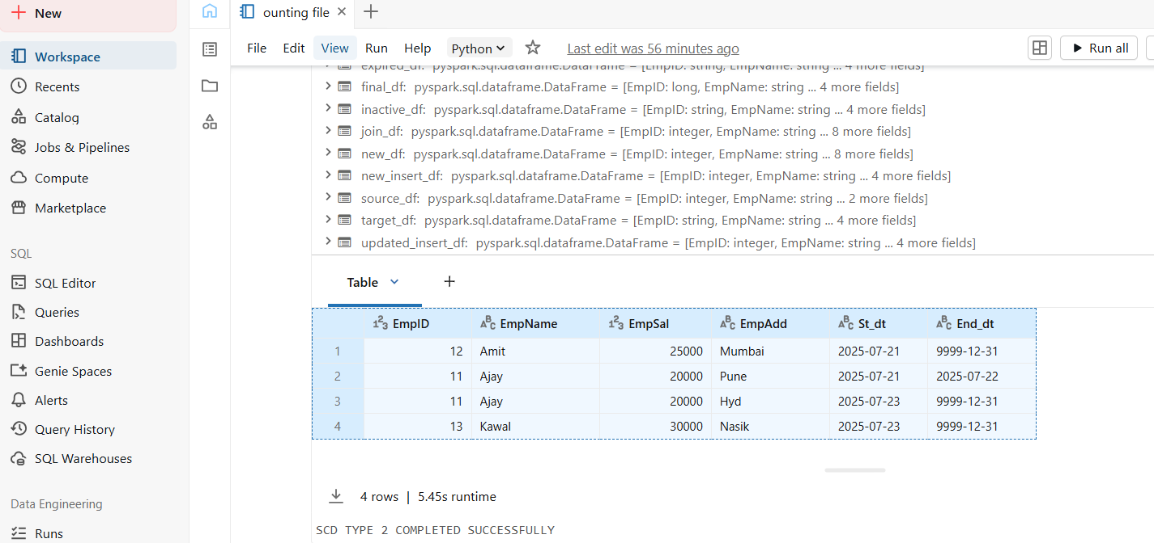

5) Azure Data Factory Automation
